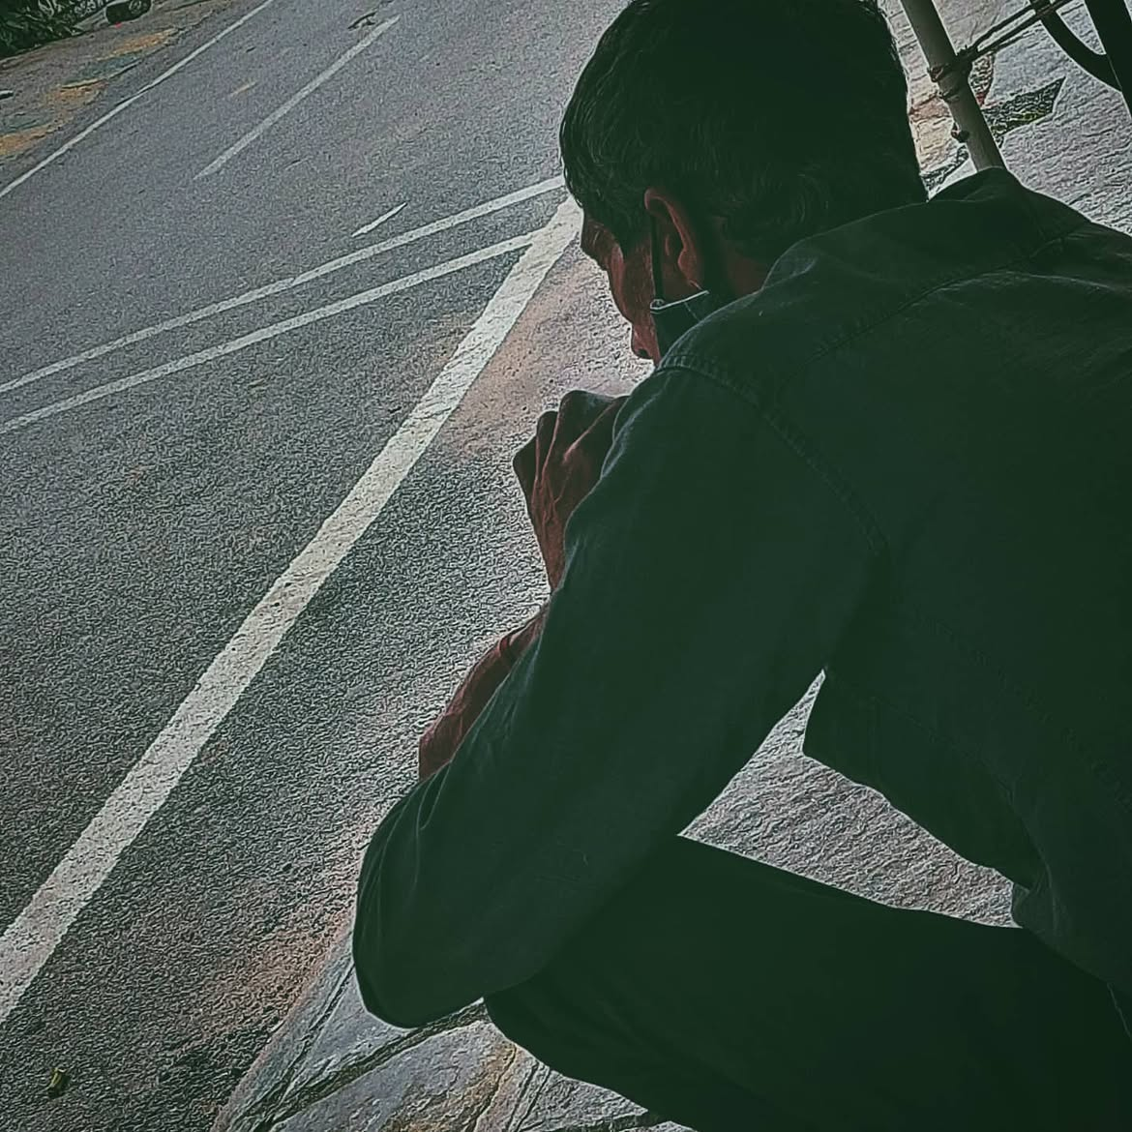
one chai, one pack of "good day" , and one bidi.

A bony frame, and a love for dogs.

Probably a good story behind him for a vulture like me, who thrives on romanticising everything.

Now I could write about the "simple goodness of life" , or about the complications that led him to be here, in this time, as I sit beside him just observing, making him a part of my phenomenalism without even having a conversation.

What good does any of it do if we don't really act upon our thoughts,
what good do any of these moments do if we scrutinized everything about it without taking the moment, in its simplicity, at the face value.

So let me just simplify everything I saw, not in an essay, but a 20 second read-

Man didn't have enough to eat. Dogs came around him. he shared. Dogs wanted more. He got irritated, but didn't hit them. Finished his "breakfast ", smoked a bidi, left.

That's all there is to it.

I could refer to what Krishna said in Gita about the method of helping people, or I could refer to French existentialists saying individual goodness is everything regardless of the situation.

But humans are far more complex than just philosophies and ways of life.

Humans are, well, humans.

Simplicity and complexity are two constructs we use to understand and explain the same phenomena in either a formalised or casual manner, based on our audiences, and I care about none of it.

I said what I saw; now what you understand is subject to both my verbal and your cognitive capacities.

Take away what you can.

Screw that, just be good,at least try, doesn't matter if you fail sometimes. Yeah, just that.

